Label the picture. Include labels on the all of the different parts of the bird's body.
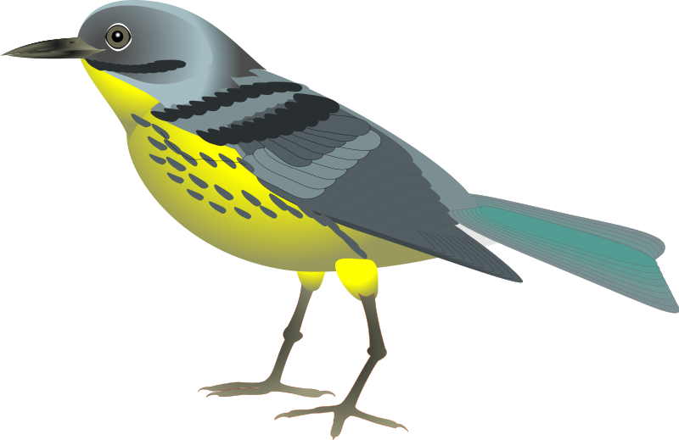

Bonus: Label the bird's gizzard, type of bones,
and circle whether he is cold or warm blooded.
Cold Blooded

Warm Blooded

