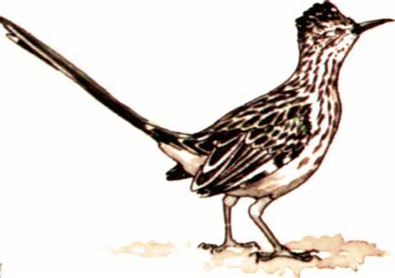
Day Two
Investigations
Why are beaks different shapes and sizes? Explain.

My Conclusion:
______________________________________________________
______________________________________________________
______________________________________________________
What three adaptations of a bird's feathers help it fly? Explain.

My Conclusion:
______________________________________________________
______________________________________________________
______________________________________________________
What is camouflage and why do birds have it?

My Conclusion:
______________________________________________________
______________________________________________________

