PG 1:
Why do birds have different size and shape beaks?
3 - wrote about how beaks are used based on what they eat and gave examples
2 - either wrote about either how beaks are different based on what they eat or gave examples
1- answer was incorrect but filled in.
0 - nothing was written

PG 2: Bird Anatomy
3- 8 or more correct
2- 4 or more correct
1 - 2 or more correct
0 - 1 or more correct

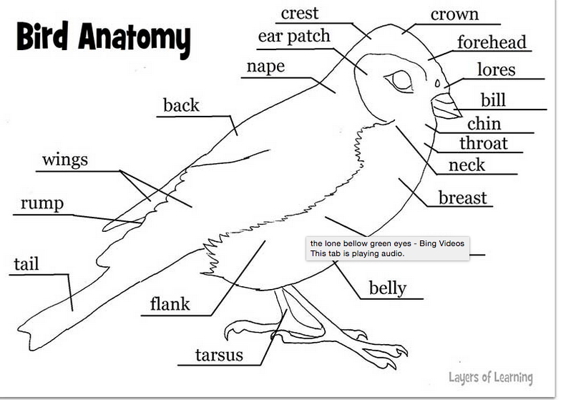

PG 3:
What adaptation does a bird have to help it fly?
2 - Mentioned wings and explained how they help the bird fly
1- mentioned wings

List five things a bird needs to survive...
5 - listed all five things correctly
4 - listed four out of five correctly
3 - listed three out of five correctly
2- listed two out of five correctly
1- listed one out of five correctly

Do you know any Navajo stories that have birds in them? If so, write about it here:
3- answered yes and could explain the story
2- answered yes
1- answered no

Name five birds found in New Mexico:
5- could list five birds found in NM
4- could list four birds found in NM
3 - could list three birds found in NM
2- could list two birds found in NM
1- could list one bird found in NM

Total Possible: 21

