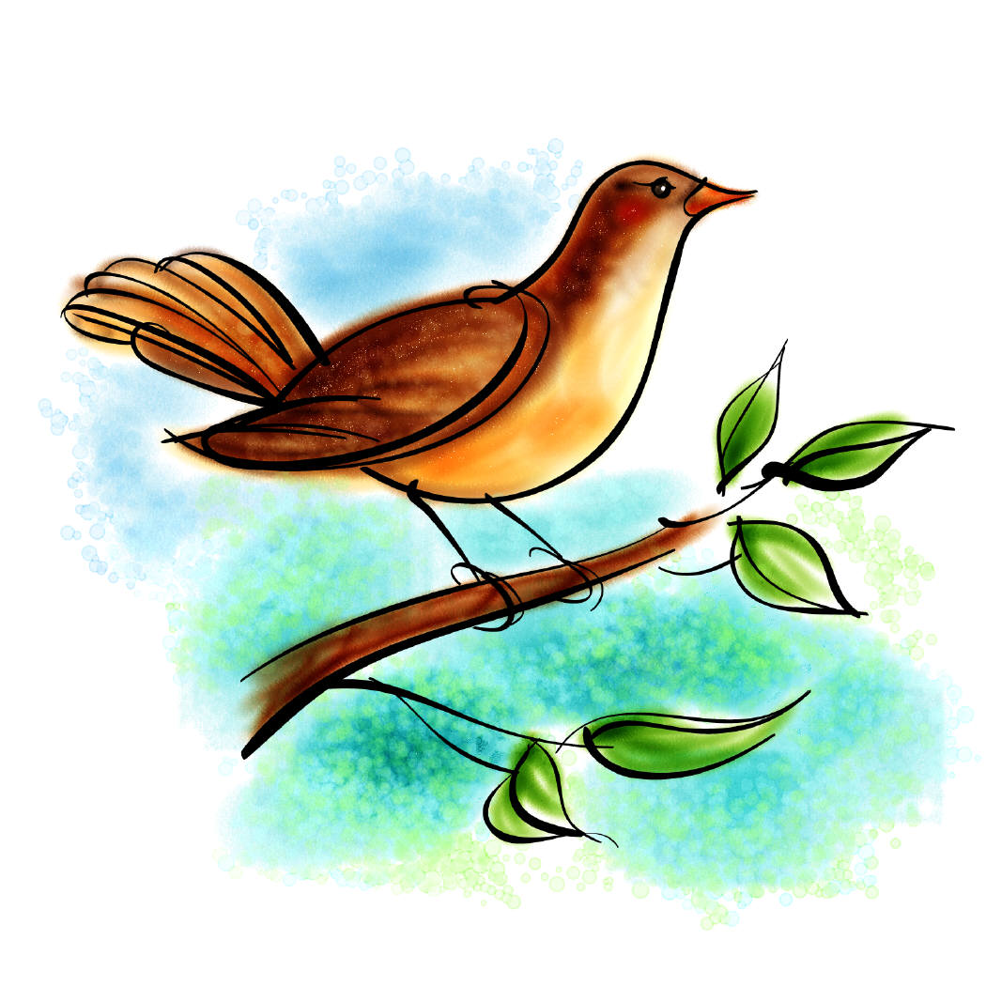
Day One Investigations
Name the one feature that makes a bird a bird according to our read aloud story.

My Conclusion:
______________________________________________________
______________________________________________________
______________________________________________________
______________________________________________________
Name and describe the parts of a bird's body that we talked about today. (Try to write as many as you can remember.)

My Conclusion:
______________________________________________________
______________________________________________________
______________________________________________________
______________________________________________________
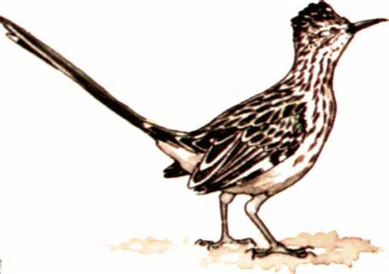
Day Two
Investigations
Why are beaks different shapes and sizes? Explain.

My Conclusion:
______________________________________________________
______________________________________________________
______________________________________________________
What three adaptations of a bird's feathers help it fly? Explain.

My Conclusion:
______________________________________________________
______________________________________________________
______________________________________________________
What is camouflage and why do birds have it?

My Conclusion:
______________________________________________________
______________________________________________________

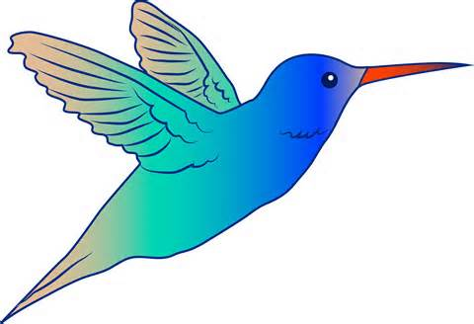 What are the five parts of a habitat?
Day Three
Investigations

My Conclusion:
______________________________________________________
______________________________________________________
______________________________________________________
______________________________________________________
Describe the perfect bird habitat. (Remember to include the five parts of a habitat.)

My Conclusion:
______________________________________________________
______________________________________________________
______________________________________________________
______________________________________________________

Day Four Investigations
Why will your bird habitat attract birds?

My Conclusion:
______________________________________________________
______________________________________________________
______________________________________________________
______________________________________________________
When do you think the first birds will come?

My Conclusion:
______________________________________________________
______________________________________________________
______________________________________________________

