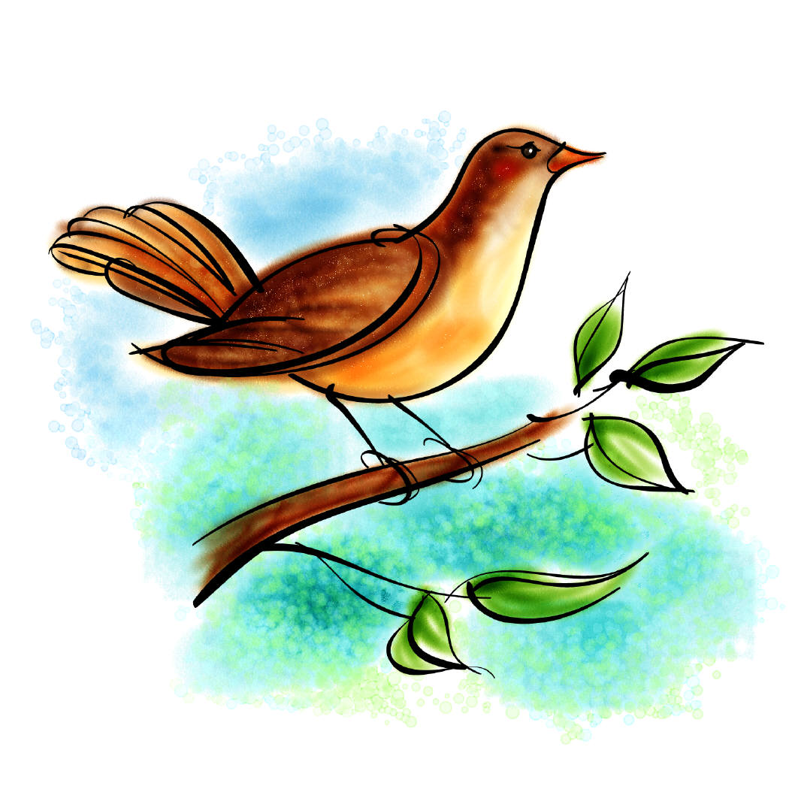
Day One Investigations
Name the one feature that makes a bird a bird according to our read aloud story.

My Conclusion:
______________________________________________________
______________________________________________________
______________________________________________________
______________________________________________________
Name and describe the parts of a bird's body that we talked about today. (Try to write as many as you can remember.)

My Conclusion:
______________________________________________________
______________________________________________________
______________________________________________________
______________________________________________________

