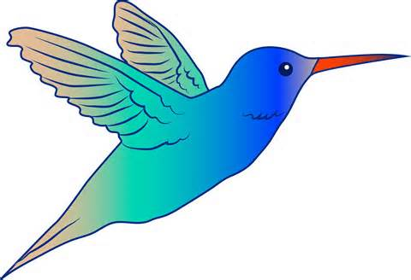 What are the five parts of a habitat?
Day Three
Investigations

My Conclusion:
______________________________________________________
______________________________________________________
______________________________________________________
______________________________________________________
Describe the perfect bird habitat. (Remember to include the five parts of a habitat.)

My Conclusion:
______________________________________________________
______________________________________________________
______________________________________________________
______________________________________________________

