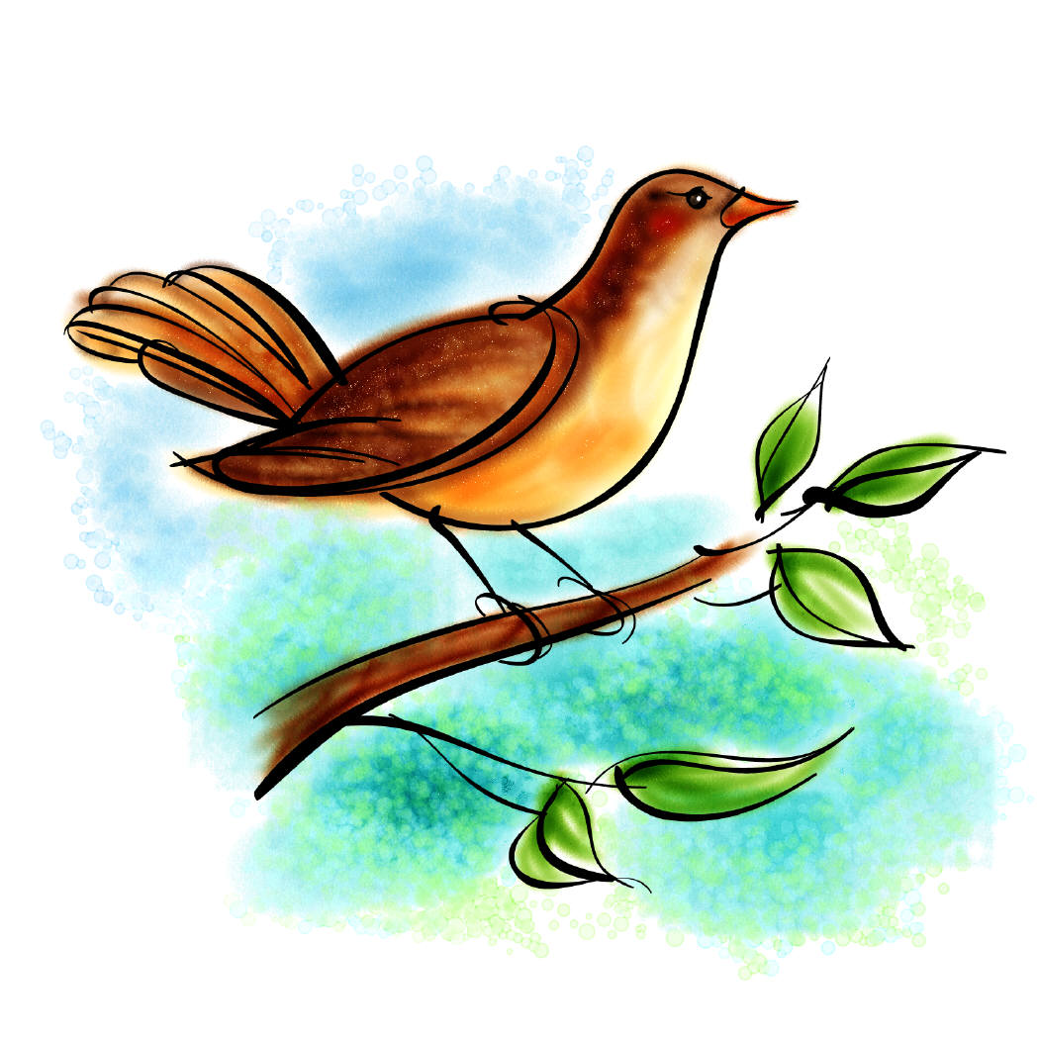
Day Four Investigations
How did you make the bird feeders?
______________________________________________________
______________________________________________________
How did you make the bird houses?

______________________________________________________
______________________________________________________
Why will your bird habitat attract birds?
______________________________________________________
______________________________________________________
When do you think the first birds will come?
______________________________________________________
______________________________________________________

